CMPUT 291 – Fall 2016

MINI PROJECT 2

Group Members: Shouyang Zhou,

# Summary

The follow design document specifies the underlying implementation for mini project 2.

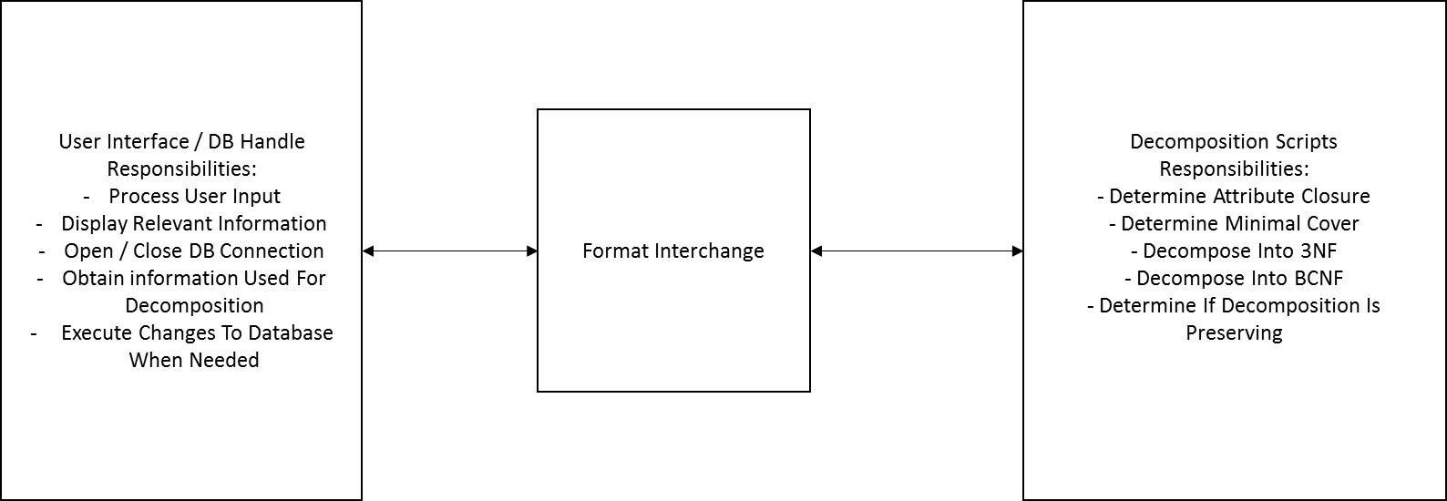

Above: General Structure of the Program.

The general structure of the program allows both sides to be tested and developed simultaneously. This separation of responsibilities allows for better organization, testing, and the ability to demonstrate one side independent of the other. A drawback is the need for some sort of format converter. The decomposition script requires a generalized format, while tabular data stored in the database is of different format. Overall this is not a large concern.

# User Guide

<TODO>

# Testing Strategy

# Work Breakdown Strategy